Image | 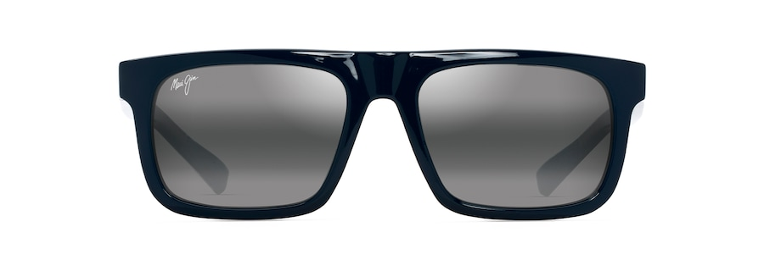
Brand | MAUI JIM
Model Name | ‘ŌPIO
Price | RS 2900
PRODUCT DETAILS

